* **Some Linux Commands.**

**ls**

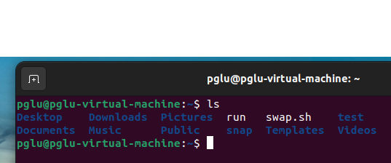

In [Linux](https://en.wikipedia.org/wiki/Linux) , the command **"ls"** is one of the most commonly used. It's used to display a list of files and sub-directories in the current directory. If you're new to using the command line, the first command you should learn is probably **ls**. This command can be used by both regular users as well as system administrators.

The ability to view what files are in a directory is what makes **ls** so important. It will be used frequently to display directory contents. Although it is not a complicated command, it does come with a number of options for listing files with additional information. Even while **ls** is always enough to list contents, you're likely to find a few of these options highly handy.

**cd**



The cd command in linux stands for **change directory**, and is used to change directory when you have a terminal window open. It's used frequently, so it is useful to know. At its most basic, when we open a new terminal window, we can use cd to navigate between directories.

**mkdir**

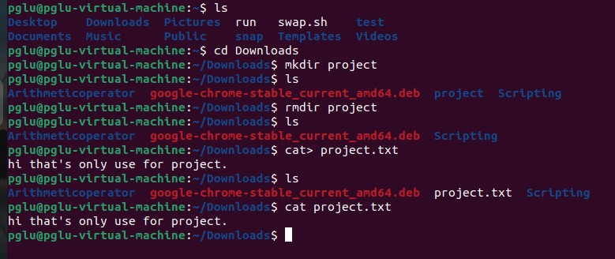

The command mkdir stands for “**make directory**”. It creates each directory specifed on the command line in the order given. It reports an error if DIRECTORY already exists, unless the -p option is given. The mkdir command in Linux/Unix allows users to create or make new directories (also referred to as folders in some operating systems).

**rmdir**



rmdir command is used**remove empty directories** from the filesystem in Linux. The rmdir command removes each and every directory specified in the command line only if these directories are empty. So, if the specified directory has some directories or files in it then this cannot be removed by rmdir command.

**rm**

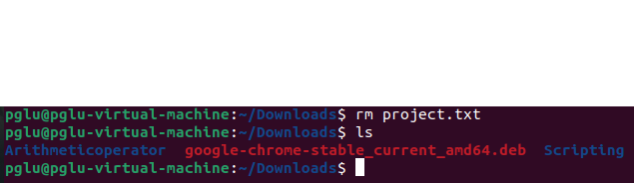

rm stands for**‘remove ‘**, as the name suggests rm command is used to delete or remove files and directory in Linux and UNIX like operating systems. If you are new to Linux then you should be very careful while running rm command because once you delete the file or directory then you cannot recover the contents of file and directory.

**cat**

Introduction to CAT Command in Linux The cat command is termed**“concatenate”** which is one of the widely used commands in Unix/Linux & Apple Mac OS operating system. This command has different applications like create single/ multiple files, view the content of the file, concatenate file and redirect their output to the terminal or file.